
SRM Institute of Science and Technology
College of Engineering and Technology
School of Computing
Department of Networking and Communications
Academic Year: 2023-24 (EVEN)
Test: CLA-T1 Date: 16.02.2024
Course Code & Title: 18CSC312 - Artificial Intelligence and Applications in Cloud Computing
Year & Sem: III Year Max. Marks: 25 Duration: 50 minutes

Course Articulation Matrix: (to be placed)
S.No. | Course Outcome | PO1 | PO2 | PO3 | PO4 | PO5 | PO6 | PO7 | PO8 | PO9 | PO10 | PO11 | PO12
1 | CO1 | M | M | M | M | H | - | - | - | M | L | - | H
2 | CO2 | M | H | H | H | H | - | - | - | M | L | - | H
3 | CO3 | M | H | H | M | H | - | - | - | M | L | - | H
4 | CO4 | M | H | M | H | H | - | - | - | M | L | - | H
5 | CO5 | H | H | H | H | H | - | - | - | M | L | - | H
6 | CO6 | L | H | M | M | H | - | - | - | H | L | - | H

Part - A
(5 x 1 = 5 Marks)
Instructions: Answer all
Q. No | Question | Marks | BL | CO | PO | PI Code
1 | What is the function of an Artificial Intelligence “Agent”?  a) Mapping of goal sequence to an action  b) Work without the direct interference of the people  c) Mapping of precept sequence to an action  d) Mapping of environment sequence to an action | 1 | L1 | 1 | 1 | 1.6.1
2 | ____ is not an application of AI.  a) Database Management System  b) Digital Assistants  c) Natural language processing  d) Computer Vision | 1 | L2 | 1 | 2 | 2.6.3
3 | How many possible solutions exist for an 8-queen problem?  a) 100  b) 98  c) 92  d) 88 | 1 | L2 | 1 | 2 | 2.6.3
4 | constraint propagation is done by  - Min- conflicts heuristics  - Max - conflicts heuristics  - arc consistency  - tree structure | 1 | L2 | 1 | 2 | 2.6.3
5 | Who is known as the -Father of AI"?  - Fisher Ada  - Alan Turing  - John McCarthy  - Allen Newell | 1 | L1 | 1 | 1 | 1.6.1
Part – B (2 x 5 = 10 Marks)
Answer any 2 Questions
6 | Explain the problem characteristics of AI.  - Is the problem decomposable ?  - Can Solution steps be ignored or undone ? Moves can be undone and backtracked.(8 puzzle , Chess)  - Is the Universe Predictable? (Cards)  - Is a good solution absolute or relative ? ( Travel Salesman Problem)  - Is the solution a state or a path? ( Water Jug Problem)  - What is the role of knowledge?  - Does the task require interaction with a person ? | 5 | L3 | 1 | 1 | 1.6.1
7 | You're leading a team in implementing a data mining and machine learning solution for a company's hiring process. Explain how you'd apply the provided concepts. Describe your strategy for data extraction, including cleaning and preprocessing, to identify relevant patterns in candidate profiles and job requirements. Discuss the use of computational learning theory models to analyze algorithm efficiency. Explain how neural and evolutionary computation methods could expedite the process. Additionally, elaborate on the role of intelligent agents and multi-agent systems in facilitating decision-making based on diverse perspectives. Lastly, discuss how multi-perspective integrated intelligence could inform hiring decisions through varied feedback channels. | 5 | L3 | 1 | 2 | 2.6.4
8 | You've been tasked with designing an algorithm to solve the classic 8-queens problem. The goal is to place eight queens on an 8x8 chessboard in such a way that no two queens threaten each other. This means that no two queens can be in the same row, column, or diagonal. The team aims to write an algorithm and create an efficient solution that can find all possible configurations of placing the queens on the board. Discuss how you would approach generating and evaluating potential queen placements while ensuring they adhere to the constraints of the problem. | 5 | L3 | 1 | 1 | 1.6.1
Part – C (1 x 10 = 10 Marks)
9 | You're leading a team developing an AI algorithm to solve cryptarithmetic problems, specifically focusing on puzzles where letters represent digits and addition operations need to be deciphered. One such puzzle involves the equationto find the value of GIFT, provided with only one clue that WAIT + ALL = GIFTS, where each letter represents a unique digit from 0 to 9. The task is to find the corresponding digit for each letter to make the equation valid. The team aims to create an efficient solver capable of handling various cryptarithmetic puzzles with minimal computational resources.  W A I T  A L L  ---------------  G I F T S  9 6 0 8  6 7 7  -----------  1 0 2 8 5  Hence G + I + F + T = 11 | 10 | L4 | 1 | 1 | 1.7.1
10 | You're leading a team tasked with developing an AI algorithm to solve the classic water jug problem, specifically focusing on a scenario with two jugs: one jug can hold 5 liters of water, and the other can hold 2 liters. The initial state of the jugs is 5 liters in the first jug and 2 liters in the second jug. The goal is to reach a state where the first jug contains 1 liter of water and the second jug is empty. The team aims to design an efficient rules capable of finding a sequence of actions to achieve this goal while minimizing the number of steps required  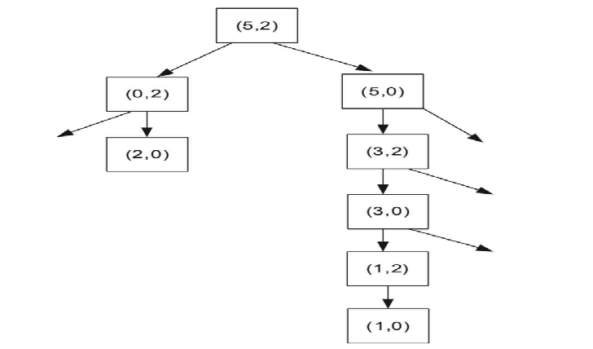 | 10 | L4 | 1 | 2 | 2.6.4

*Program Indicators are available separately for Computer Science and Engineering in AICTE examination reforms policy.

Course Outcome (CO) and Bloom’s level (BL) Coverage in Questions

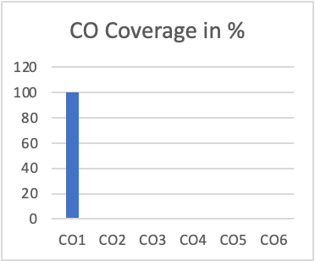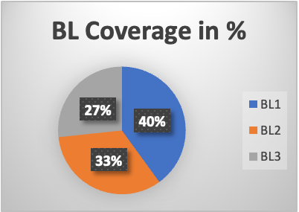

Approved by the Audit Professor/Course Coordinator

